GD GOENKA PUBLIC SCHOOL, KUPWARA
SCHOOL CLUBS
CONSTITUTION & DETAILED ACTION PLAN
Academic Session 2026–27

Prepared & Coordinated by
Qurat Fayaz
Overall Club Coordination, Monitoring & Documentation

VISUAL ACTIVITY GUIDE

1. Purpose of the School Clubs
The school clubs are being constituted to provide students with meaningful opportunities for experiential, activity-based and project-based learning. Every club will work towards a tangible outcome such as a model, campaign, exhibition, competition, research product, service initiative or performance. The clubs are not intended to function as routine meeting or discussion groups.

2. Overall Coordination & Monitoring – Qurat Fayaz
I will oversee the functioning of all nine clubs. She will coordinate with club in-charges, monitor implementation, check that activities are conducted as planned, collect evidence of student participation and outcomes, maintain the consolidated documentation, and prepare progress updates for management.
- Coordinate with all club in-charges and follow up on implementation.
- Maintain the master record of club constitution, student membership and activities.
- Check that every club initiates its first activity at the earliest.
- Monitor whether activities are genuinely project/activity-based and student-led.
- Collect activity reports and photographs of actual school activities.
- Review club portfolios and follow up on pending documentation.
- Compile a consolidated visual report for management.
- Review progress at the end of each term and recommend improvements.

3. Common Responsibilities of Club In-Charges
- Maintain the student membership list.
- Prepare and implement activity plans.
- Divide students into groups and assign roles.
- Ensure active, hands-on participation.
- Coordinate with supporting teachers where needed.
- Maintain a club portfolio/file.
- Take appropriate photographs of actual activities and preserve student work.
- Prepare a brief report after each major activity.
- Submit photographs and reports to Qurrat Fayaz for consolidation.
- Ensure activities are safe, age-appropriate and inclusive.

4. Club-Wise Detailed Action Plans
The visuals placed under each activity are custom-made illustrative guides created specifically for this document. They are not actual school photographs and are not repeated. Their purpose is to show teachers and students what the proposed activity could look like and what type of student output is expected. After implementation, actual GD Goenka photographs should be added to the activity report as evidence.

1. Environment & Eco Club
Teacher In-Charge(s): Mudassir Sir & Javed Sir
Objectives
- Develop environmental awareness and responsibility.
- Promote plantation, recycling, waste segregation and conservation.
- Help students understand environmental issues through practical projects.
Teacher Responsibility
The in-charge teacher(s) will plan the activity, brief students, organise resources and groups, supervise implementation, ensure a tangible outcome, take photographs of the actual activity, and submit the activity report and evidence to Qurrat Fayaz.

1. School Plantation / Adopt-a-Plant Drive
Students plant/adopt saplings in groups and take responsibility for their care.
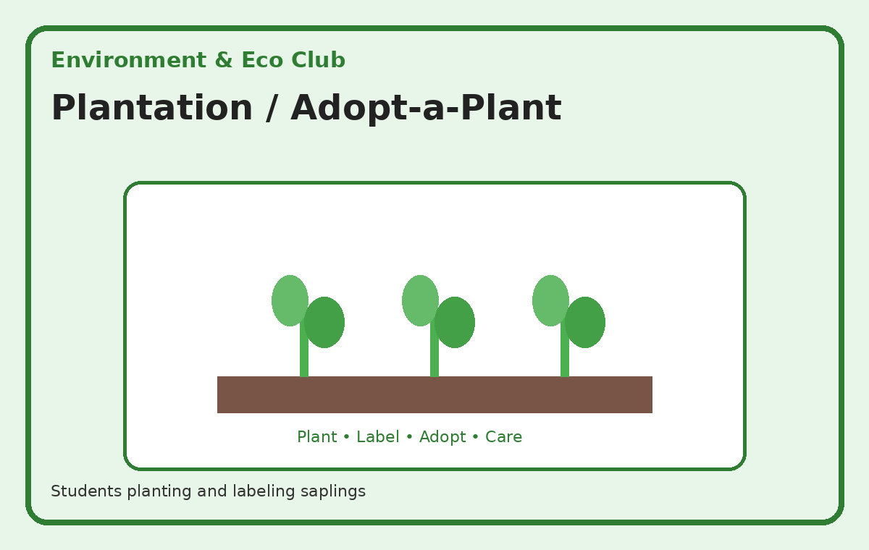
Illustrative activity guide — custom visual created for this action plan
Expected student outcome: A visible/tangible outcome such as a model, display, record, presentation, campaign material, product, performance or service result.
Actual documentation after implementation: Participation record + actual school photographs + short activity report + final student outcome.

2. Waste Segregation Project
Students identify wet, dry and recyclable waste and create a practical segregation system.
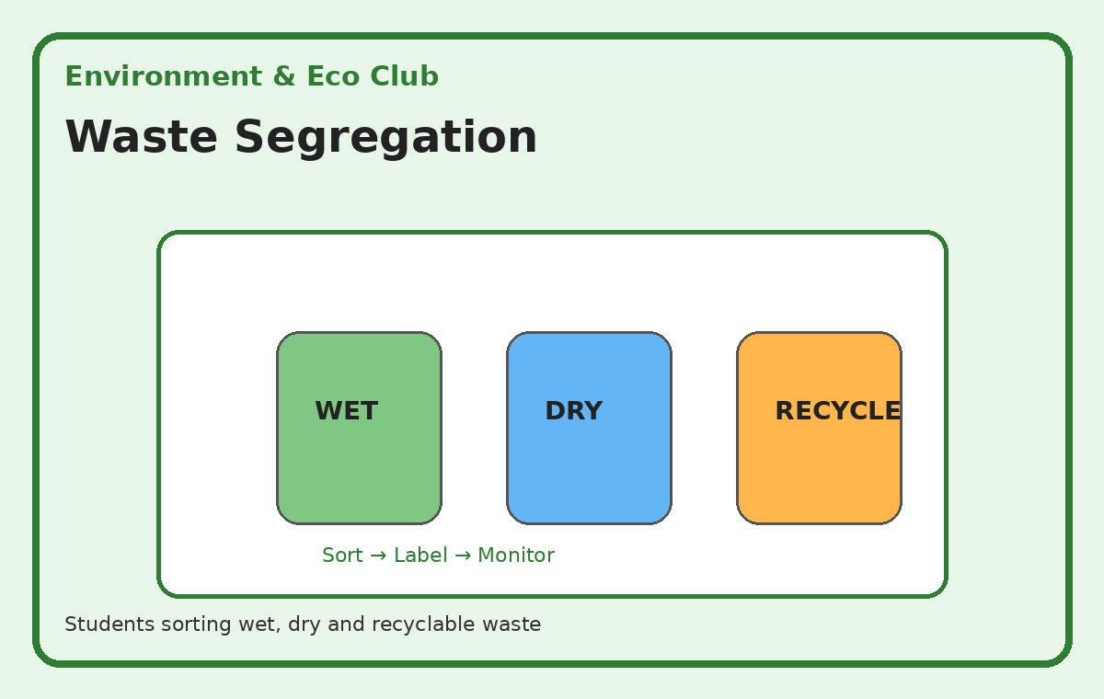
Illustrative activity guide — custom visual created for this action plan
Expected student outcome: A visible/tangible outcome such as a model, display, record, presentation, campaign material, product, performance or service result.
Actual documentation after implementation: Participation record + actual school photographs + short activity report + final student outcome.

3. Best Out of Waste Project
Students transform safe discarded materials into useful or decorative objects.
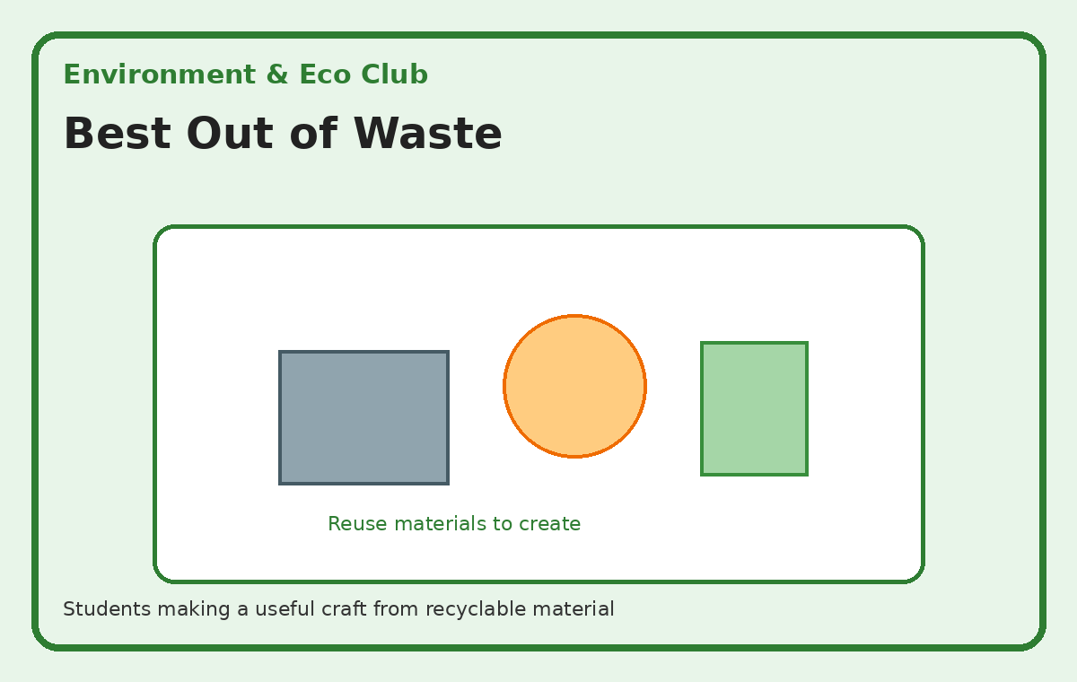
Illustrative activity guide — custom visual created for this action plan
Expected student outcome: A visible/tangible outcome such as a model, display, record, presentation, campaign material, product, performance or service result.
Actual documentation after implementation: Participation record + actual school photographs + short activity report + final student outcome.

4. School Environmental Audit
Students survey the school grounds for waste, water, greenery and energy-conservation opportunities.
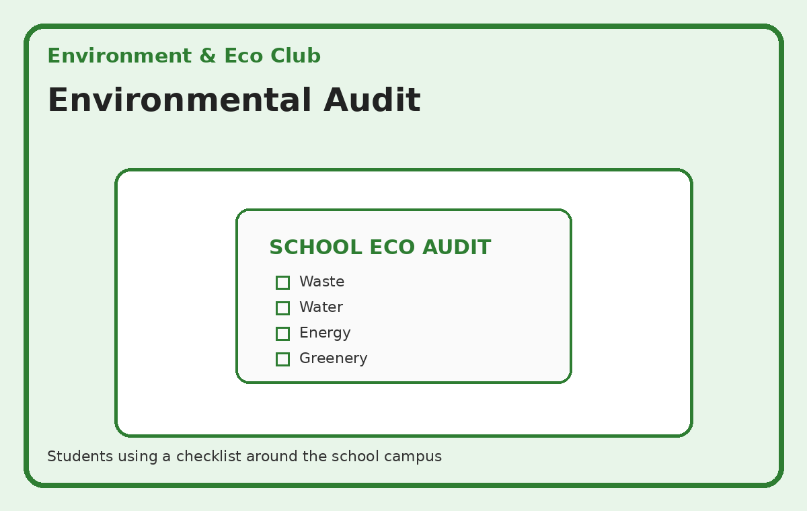
Illustrative activity guide — custom visual created for this action plan
Expected student outcome: A visible/tangible outcome such as a model, display, record, presentation, campaign material, product, performance or service result.
Actual documentation after implementation: Participation record + actual school photographs + short activity report + final student outcome.

5. Eco-Awareness Campaign
Students create posters, slogans and displays promoting environmental protection.
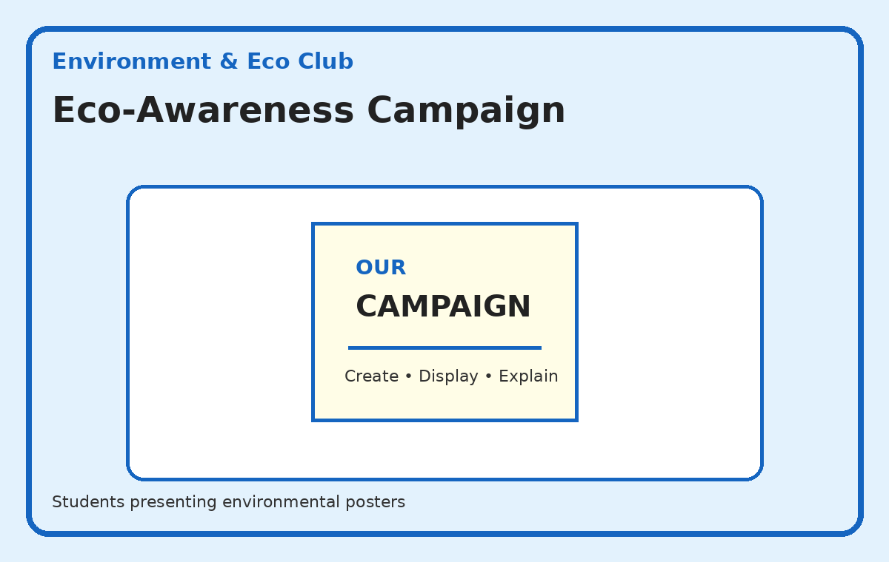
Illustrative activity guide — custom visual created for this action plan
Expected student outcome: A visible/tangible outcome such as a model, display, record, presentation, campaign material, product, performance or service result.
Actual documentation after implementation: Participation record + actual school photographs + short activity report + final student outcome.

2. Robotics & AI Club
Teacher In-Charge(s): Aamir Sir & Shahista Ma’am
Objectives
- Develop interest in technology, coding and innovation.
- Introduce basic robotics and artificial intelligence concepts.
- Develop computational thinking and problem-solving skills.
Teacher Responsibility
The in-charge teacher(s) will plan the activity, brief students, organise resources and groups, supervise implementation, ensure a tangible outcome, take photographs of the actual activity, and submit the activity report and evidence to Qurrat Fayaz.

1. Introduction to Coding
Students work in pairs on a simple block-coding task and test their programs.
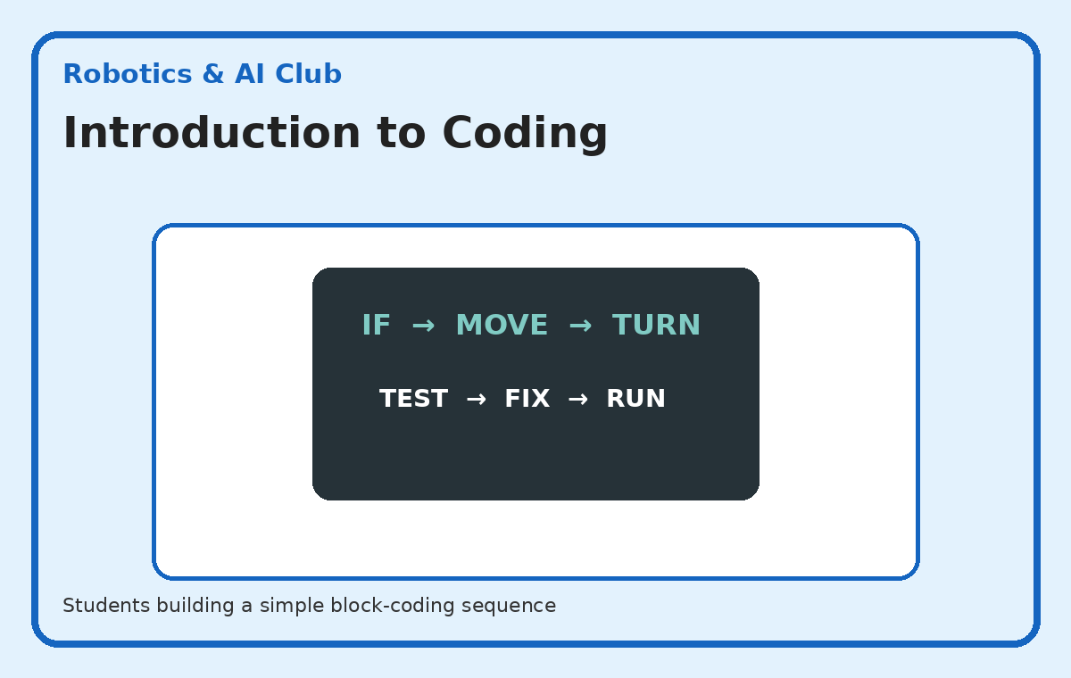
Illustrative activity guide — custom visual created for this action plan
Expected student outcome: A visible/tangible outcome such as a model, display, record, presentation, campaign material, product, performance or service result.
Actual documentation after implementation: Participation record + actual school photographs + short activity report + final student outcome.

2. Simple Robotics Project
Students assemble/program a basic robot or sensor-based model.
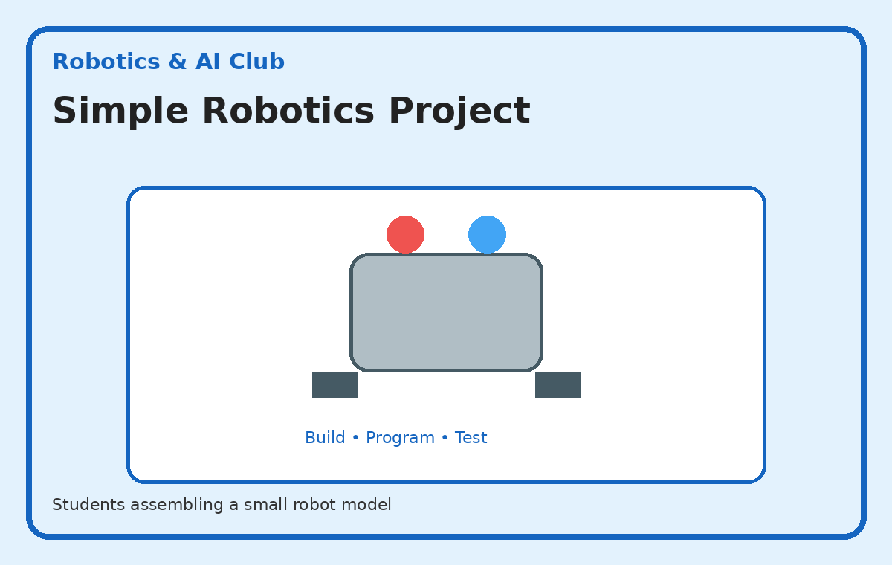
Illustrative activity guide — custom visual created for this action plan
Expected student outcome: A visible/tangible outcome such as a model, display, record, presentation, campaign material, product, performance or service result.
Actual documentation after implementation: Participation record + actual school photographs + short activity report + final student outcome.

3. AI Around Us
Students identify everyday uses of AI and explain what the technology is doing.
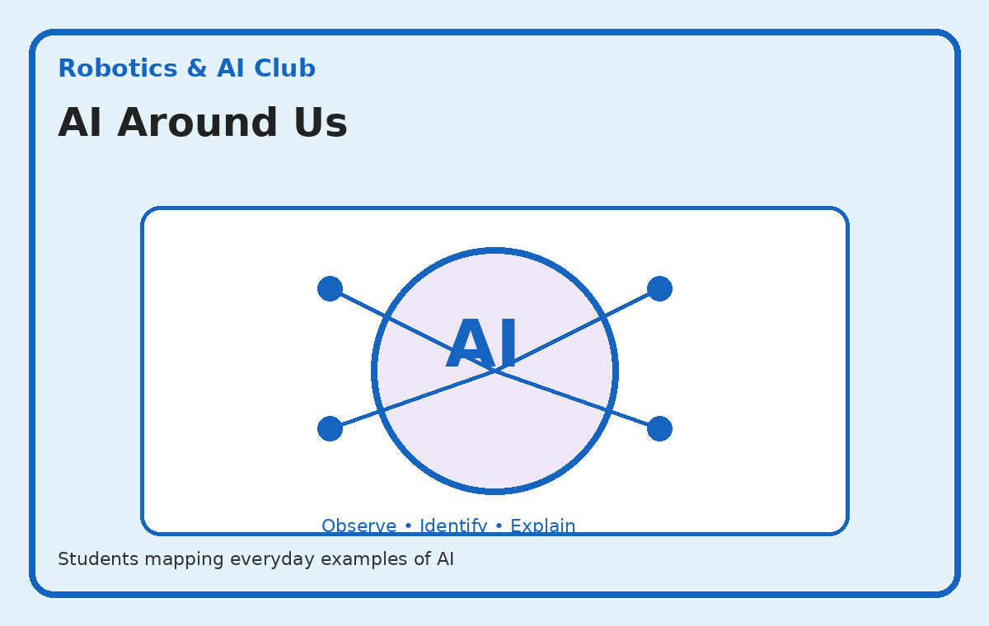
Illustrative activity guide — custom visual created for this action plan
Expected student outcome: A visible/tangible outcome such as a model, display, record, presentation, campaign material, product, performance or service result.
Actual documentation after implementation: Participation record + actual school photographs + short activity report + final student outcome.

4. Innovation Challenge
Teams design a technology-based solution to a simple school/community problem.
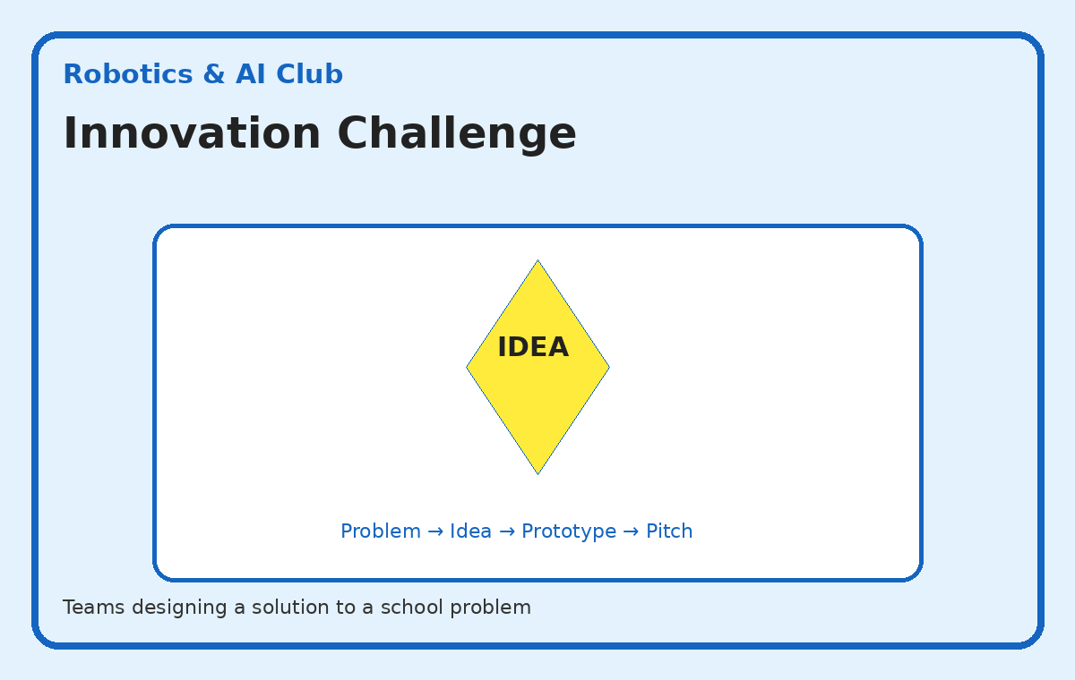
Illustrative activity guide — custom visual created for this action plan
Expected student outcome: A visible/tangible outcome such as a model, display, record, presentation, campaign material, product, performance or service result.
Actual documentation after implementation: Participation record + actual school photographs + short activity report + final student outcome.

5. Student Tech Exhibition
Students display working models, coding projects and AI ideas and explain them to visitors.
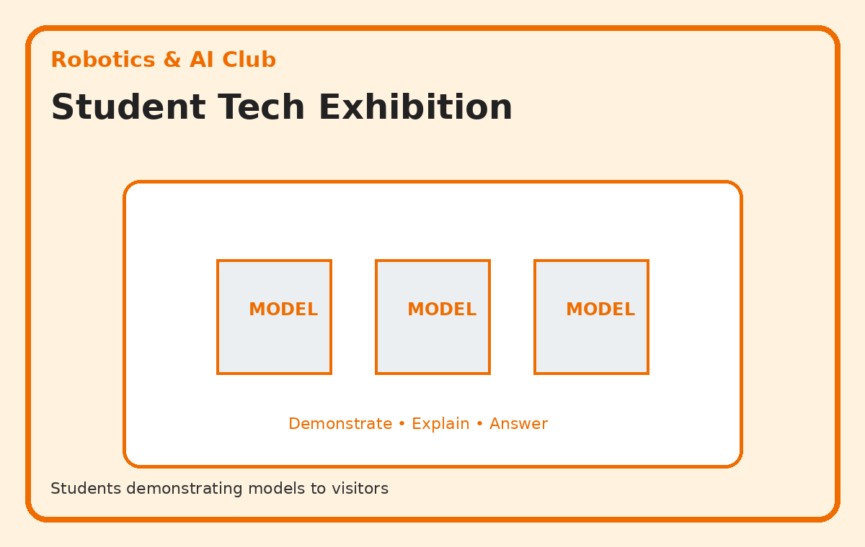
Illustrative activity guide — custom visual created for this action plan
Expected student outcome: A visible/tangible outcome such as a model, display, record, presentation, campaign material, product, performance or service result.
Actual documentation after implementation: Participation record + actual school photographs + short activity report + final student outcome.

3. Critical Thinking Club
Teacher In-Charge(s): Iram Ma’am &Sharika Maam
Objectives
- Develop logical and analytical thinking.
- Improve general knowledge and awareness.
- Encourage reasoning, questioning, communication and decision-making.
Teacher Responsibility
The in-charge teacher(s) will plan the activity, brief students, organise resources and groups, supervise implementation, ensure a tangible outcome, take photographs of the actual activity, and submit the activity report and evidence to Qurat Fayaz.

1. GK Challenge
Teams answer timed GK questions using a quiz-board/buzzer-style format.
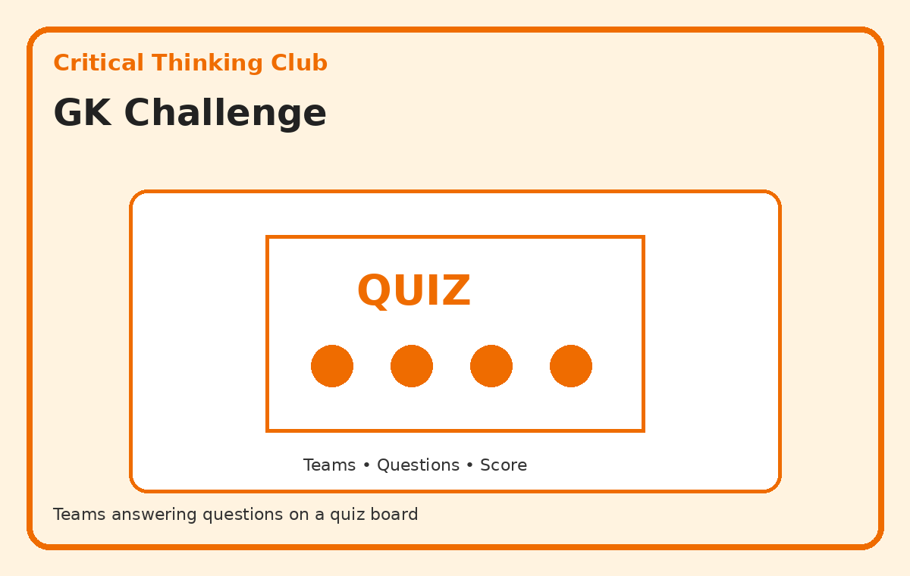
Illustrative activity guide — custom visual created for this action plan
Expected student outcome: A visible/tangible outcome such as a model, display, record, presentation, campaign material, product, performance or service result.
Actual documentation after implementation: Participation record + actual school photographs + short activity report + final student outcome.

2. Quiz Competition
Students compete in structured rounds with scorekeeping and team roles.
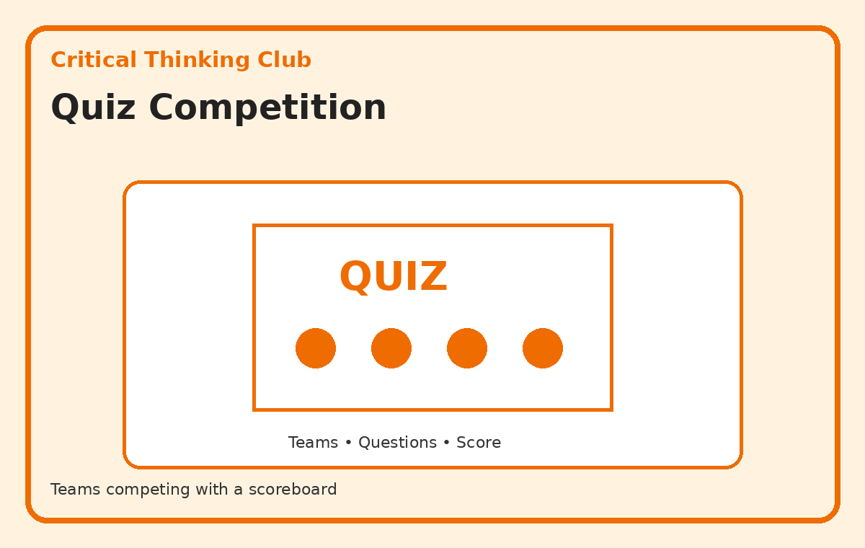
Illustrative activity guide — custom visual created for this action plan
Expected student outcome: A visible/tangible outcome such as a model, display, record, presentation, campaign material, product, performance or service result.
Actual documentation after implementation: Participation record + actual school photographs + short activity report + final student outcome.

3. Current Affairs Board
Student teams research age-appropriate current events and create a display.
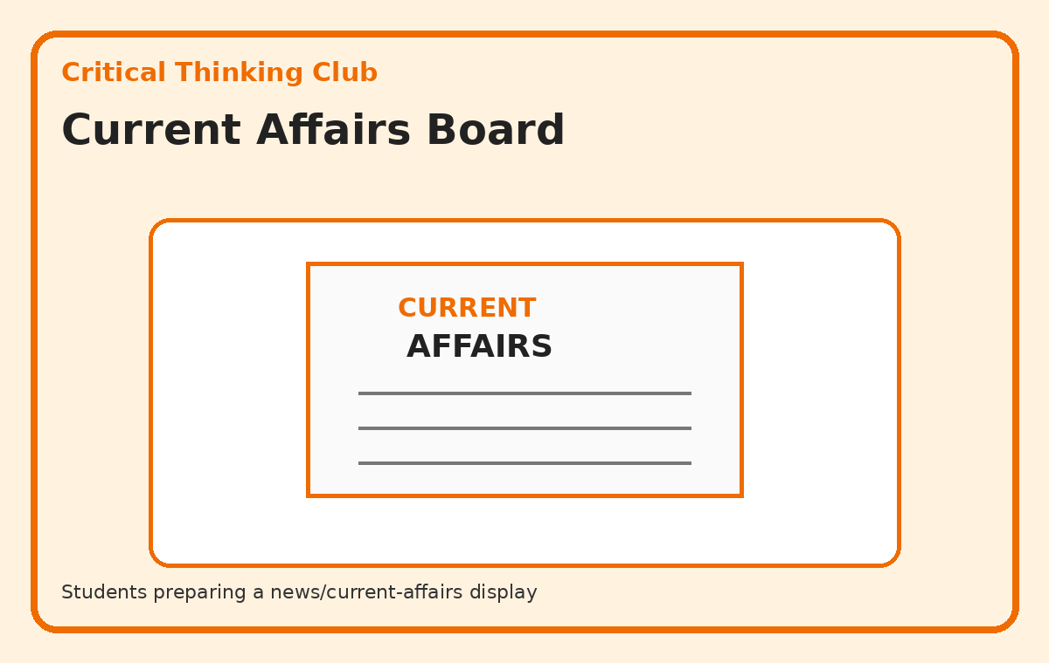
Illustrative activity guide — custom visual created for this action plan
Expected student outcome: A visible/tangible outcome such as a model, display, record, presentation, campaign material, product, performance or service result.
Actual documentation after implementation: Participation record + actual school photographs + short activity report + final student outcome.

4. Puzzle & Reasoning Challenge
Students solve logic puzzles, riddles, patterns and reasoning tasks in teams.
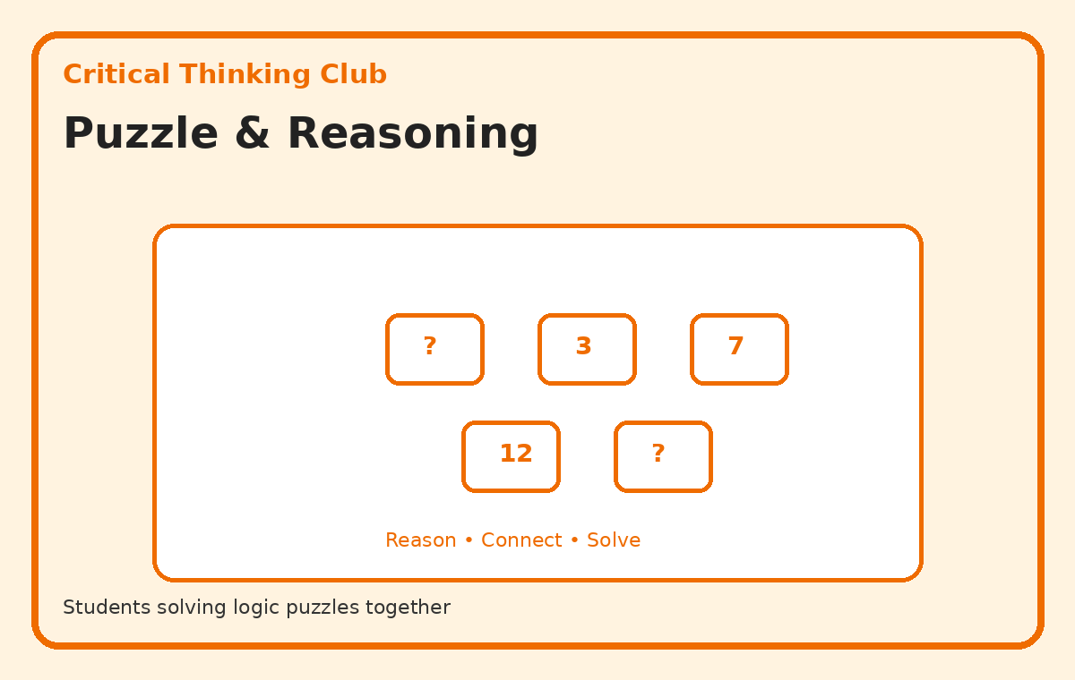
Illustrative activity guide — custom visual created for this action plan
Expected student outcome: A visible/tangible outcome such as a model, display, record, presentation, campaign material, product, performance or service result.
Actual documentation after implementation: Participation record + actual school photographs + short activity report + final student outcome.

5. Debate & Discussion Project
Students prepare short arguments for and against an age-appropriate topic and present them.
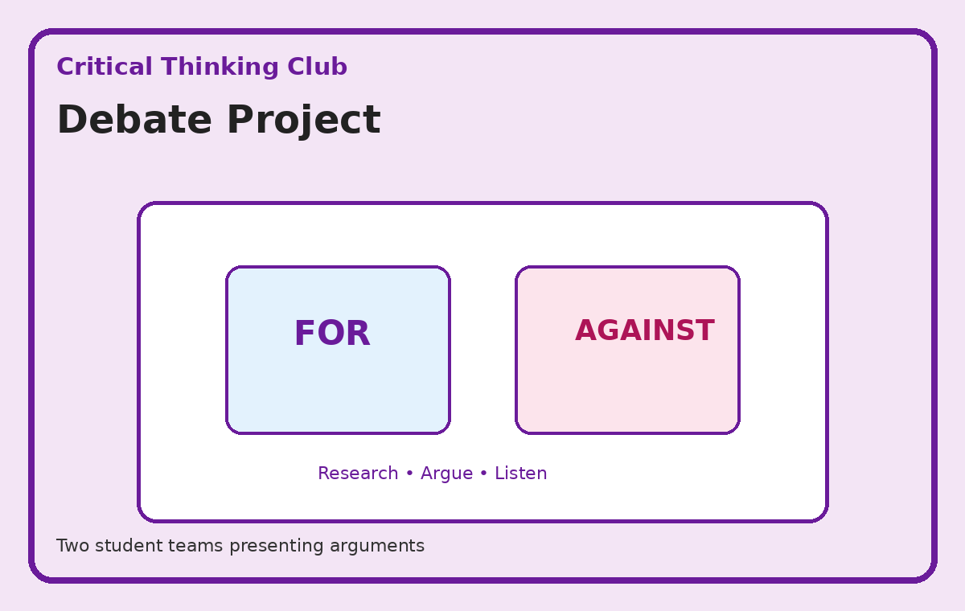
Illustrative activity guide — custom visual created for this action plan
Expected student outcome: A visible/tangible outcome such as a model, display, record, presentation, campaign material, product, performance or service result.
Actual documentation after implementation: Participation record + actual school photographs + short activity report + final student outcome.

4. Arts & Creativity Club
Teacher In-Charge(s): Gurmeet Ma’am & Maheen Ma’am
Objectives
- Develop creativity and artistic expression.
- Encourage experimentation with art and craft.
- Promote teamwork through collaborative creative projects.
Teacher Responsibility
The in-charge teacher(s) will plan the activity, brief students, organise resources and groups, supervise implementation, ensure a tangible outcome, take photographs of the actual activity, and submit the activity report and evidence to Qurrat Fayaz.

1. School Wall Project
Students collaboratively design and paint an approved educational/creative wall section.
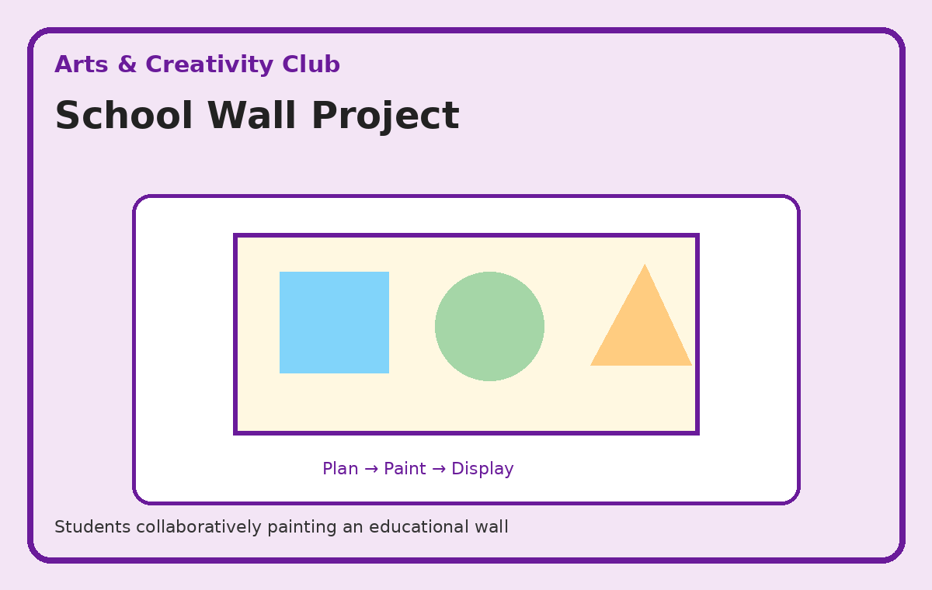
Illustrative activity guide — custom visual created for this action plan
Expected student outcome: A visible/tangible outcome such as a model, display, record, presentation, campaign material, product, performance or service result.
Actual documentation after implementation: Participation record + actual school photographs + short activity report + final student outcome.

2. Craft from Waste
Students use safe recyclable materials to create useful or decorative craft items.
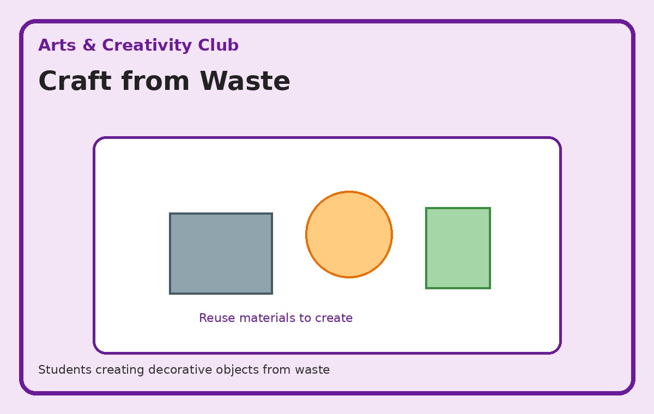
Illustrative activity guide — custom visual created for this action plan
Expected student outcome: A visible/tangible outcome such as a model, display, record, presentation, campaign material, product, performance or service result.
Actual documentation after implementation: Participation record + actual school photographs + short activity report + final student outcome.

3. Poster & Design Project
Students create themed posters for school events and awareness campaigns.
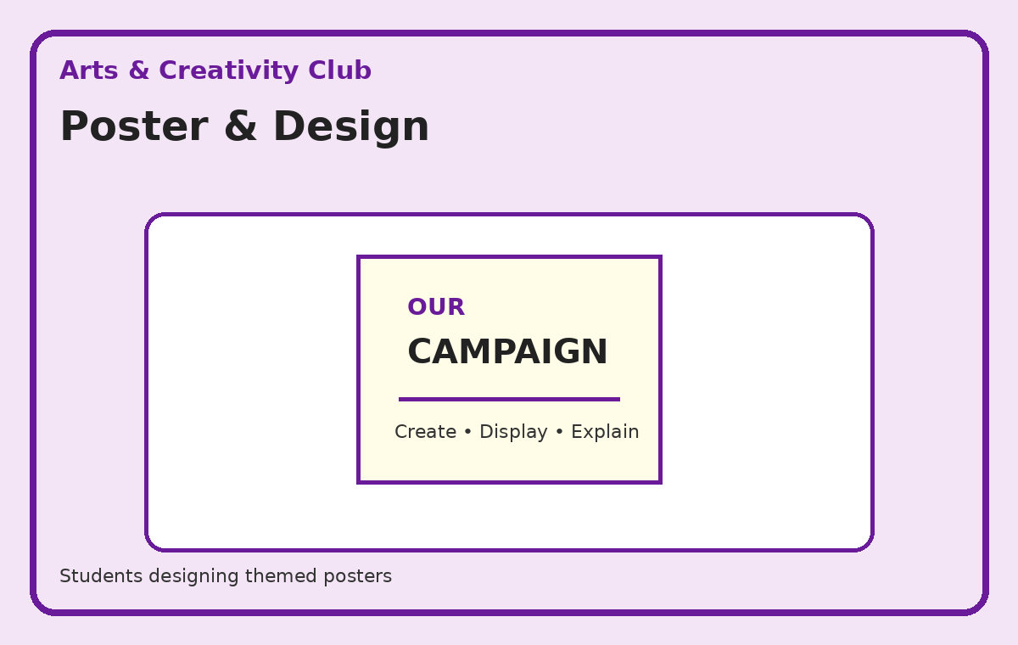
Illustrative activity guide — custom visual created for this action plan
Expected student outcome: A visible/tangible outcome such as a model, display, record, presentation, campaign material, product, performance or service result.
Actual documentation after implementation: Participation record + actual school photographs + short activity report + final student outcome.

4. Creative Exhibition
Students curate and display selected artwork, craft and design work.
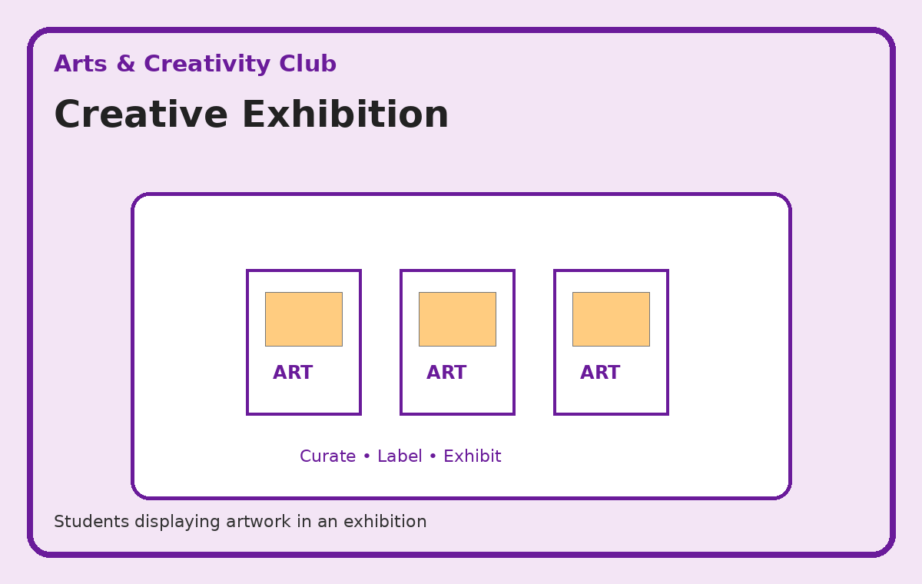
Illustrative activity guide — custom visual created for this action plan
Expected student outcome: A visible/tangible outcome such as a model, display, record, presentation, campaign material, product, performance or service result.
Actual documentation after implementation: Participation record + actual school photographs + short activity report + final student outcome.

5. Photography Project
Students document school life, nature or project work using simple composition ideas.
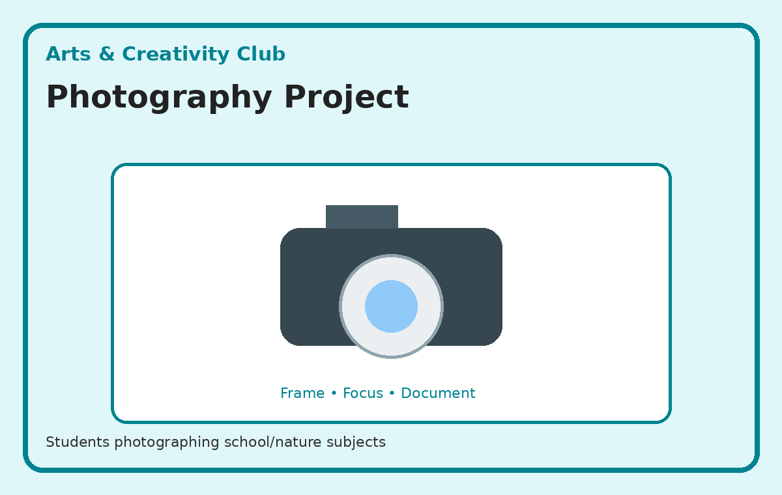
Illustrative activity guide — custom visual created for this action plan
Expected student outcome: A visible/tangible outcome such as a model, display, record, presentation, campaign material, product, performance or service result.
Actual documentation after implementation: Participation record + actual school photographs + short activity report + final student outcome.

5. Sports & Fitness Club
Teacher In-Charge(s): Rukhsana Ma’am & Farooq Sir
Objectives
- Promote physical fitness and healthy habits.
- Encourage teamwork, discipline and sportsmanship.
- Promote regular physical activity and healthy lifestyle awareness.
Teacher Responsibility
The in-charge teacher(s) will plan the activity, brief students, organise resources and groups, supervise implementation, ensure a tangible outcome, take photographs of the actual activity, and submit the activity report and evidence to Qurrat Fayaz.

1. Fitness Challenge
Students participate in age-appropriate fitness stations and team challenges.
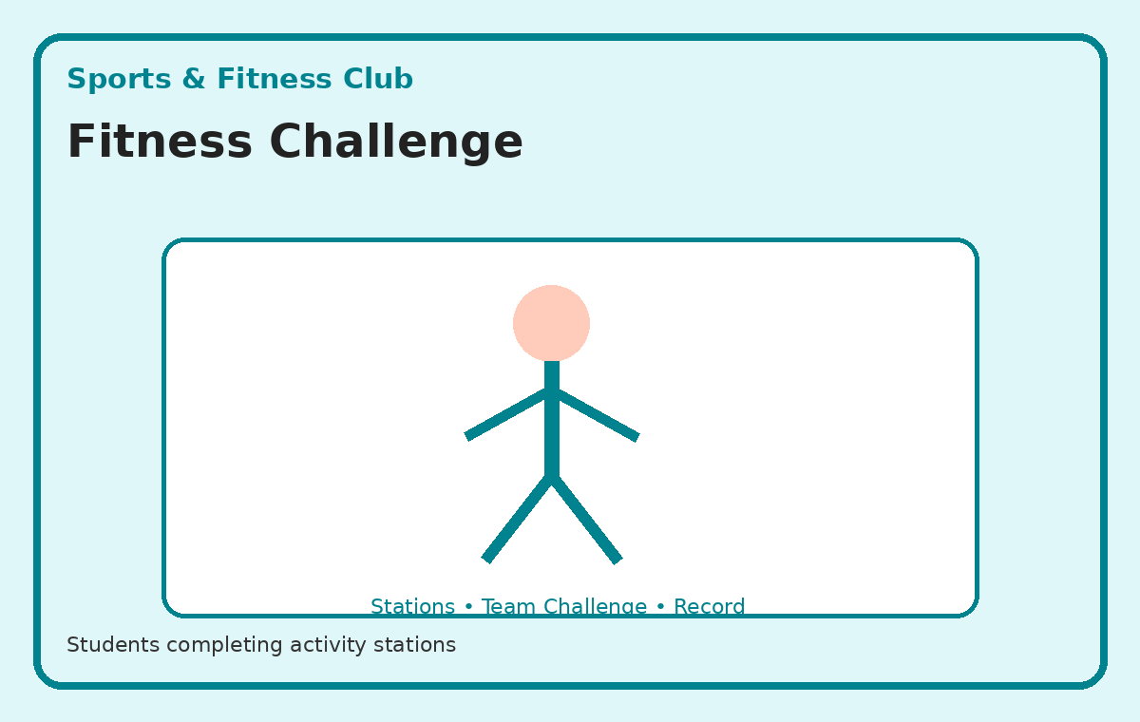
Illustrative activity guide — custom visual created for this action plan
Expected student outcome: A visible/tangible outcome such as a model, display, record, presentation, campaign material, product, performance or service result.
Actual documentation after implementation: Participation record + actual school photographs + short activity report + final student outcome.

2. Yoga Sessions
Students practise guided yoga, breathing and stretching routines.
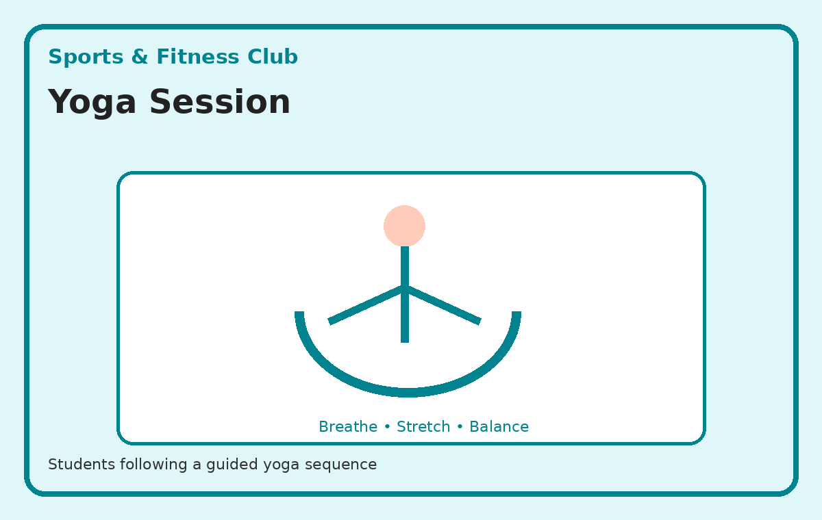
Illustrative activity guide — custom visual created for this action plan
Expected student outcome: A visible/tangible outcome such as a model, display, record, presentation, campaign material, product, performance or service result.
Actual documentation after implementation: Participation record + actual school photographs + short activity report + final student outcome.

3. Sports Skills Project
Groups practise and demonstrate basic skills in selected sports.
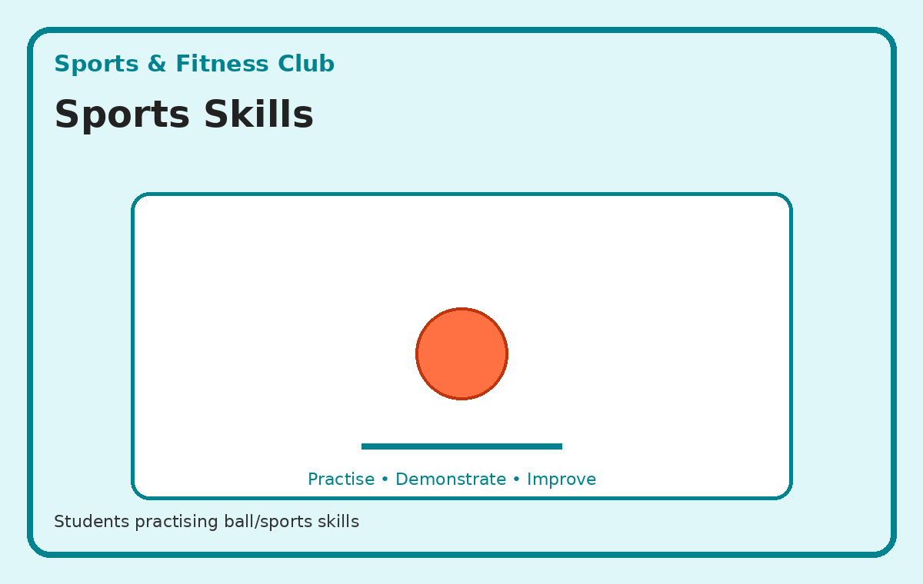
Illustrative activity guide — custom visual created for this action plan
Expected student outcome: A visible/tangible outcome such as a model, display, record, presentation, campaign material, product, performance or service result.
Actual documentation after implementation: Participation record + actual school photographs + short activity report + final student outcome.

4. Fitness Awareness Campaign
Students create displays/messages encouraging daily movement and healthy habits.
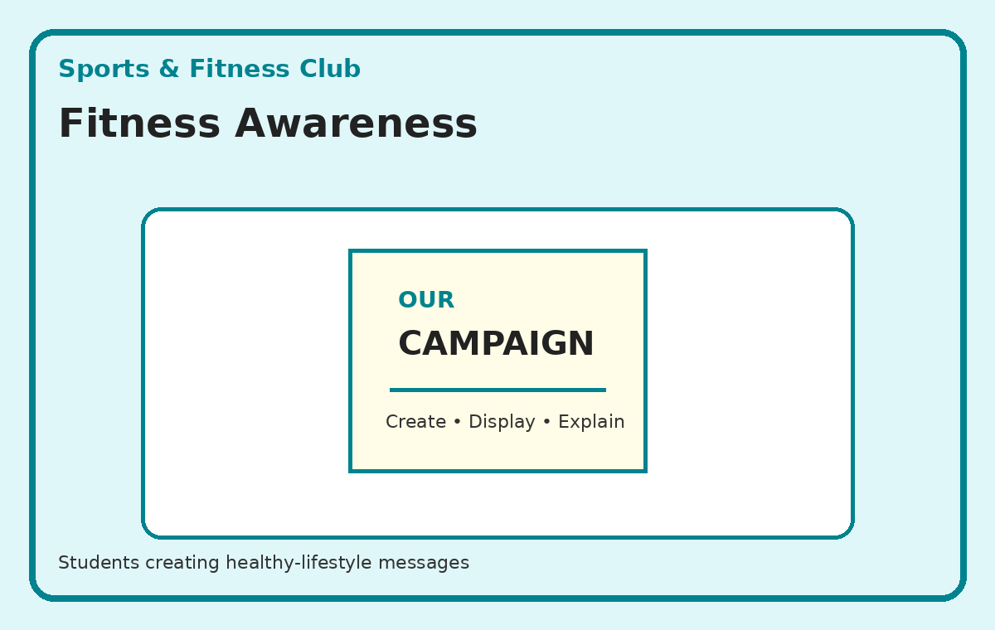
Illustrative activity guide — custom visual created for this action plan
Expected student outcome: A visible/tangible outcome such as a model, display, record, presentation, campaign material, product, performance or service result.
Actual documentation after implementation: Participation record + actual school photographs + short activity report + final student outcome.

5. Nutrition Awareness Activity
Students create a simple healthy-plate/healthy-habits display and discuss balanced choices.
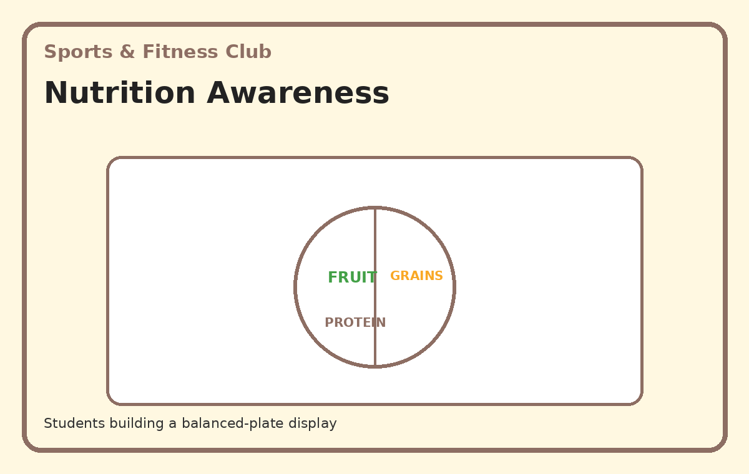
Illustrative activity guide — custom visual created for this action plan
Expected student outcome: A visible/tangible outcome such as a model, display, record, presentation, campaign material, product, performance or service result.
Actual documentation after implementation: Participation record + actual school photographs + short activity report + final student outcome.

6. Financial Literacy & Entrepreneurship Club
Teacher In-Charge(s): Falak Ma’am ,Henna Ma’am & Ghulam Muhammad Wani Sir
Objectives
- Develop basic financial awareness.
- Introduce saving, budgeting and responsible spending.
- Develop entrepreneurial thinking and creativity.
Teacher Responsibility
The in-charge teacher(s) will plan the activity, brief students, organise resources and groups, supervise implementation, ensure a tangible outcome, take photographs of the actual activity, and submit the activity report and evidence to Qurrat Fayaz.

1. Mock Market
Students set up a simulated marketplace with products, prices, buyers, sellers and play money.
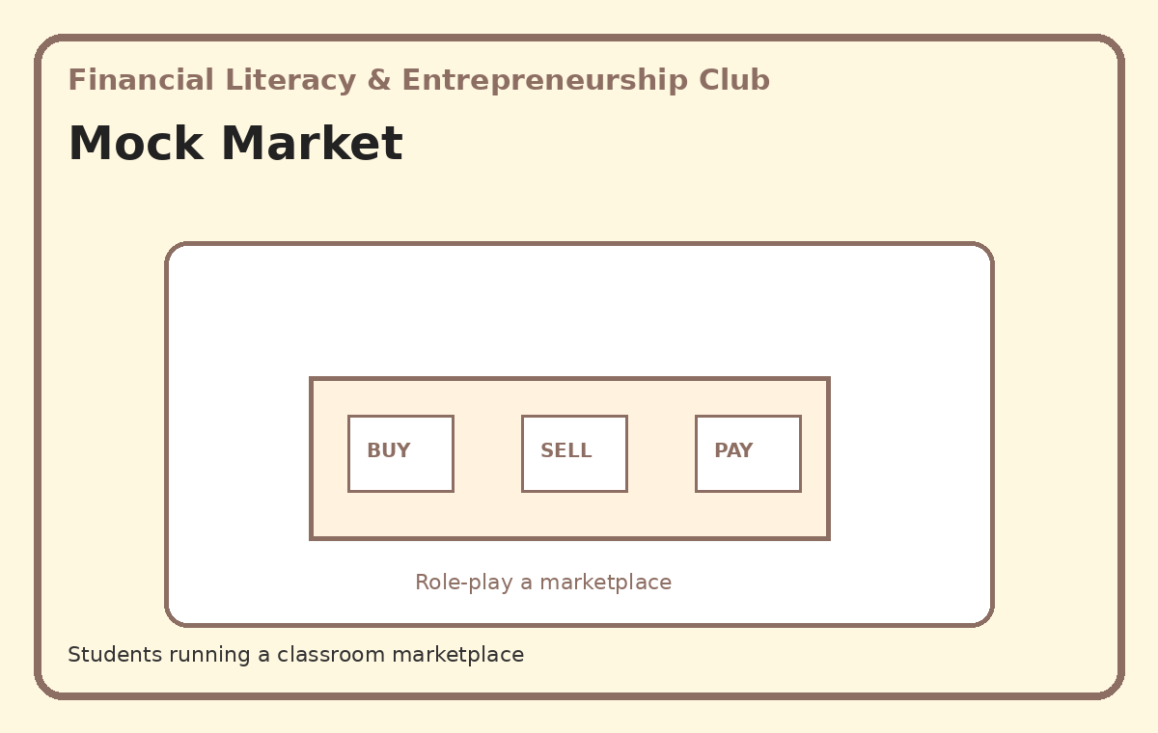
Illustrative activity guide — custom visual created for this action plan
Expected student outcome: A visible/tangible outcome such as a model, display, record, presentation, campaign material, product, performance or service result.
Actual documentation after implementation: Participation record + actual school photographs + short activity report + final student outcome.

2. Budgeting Activity
Students receive a hypothetical amount and prepare a needs/wants/savings budget.
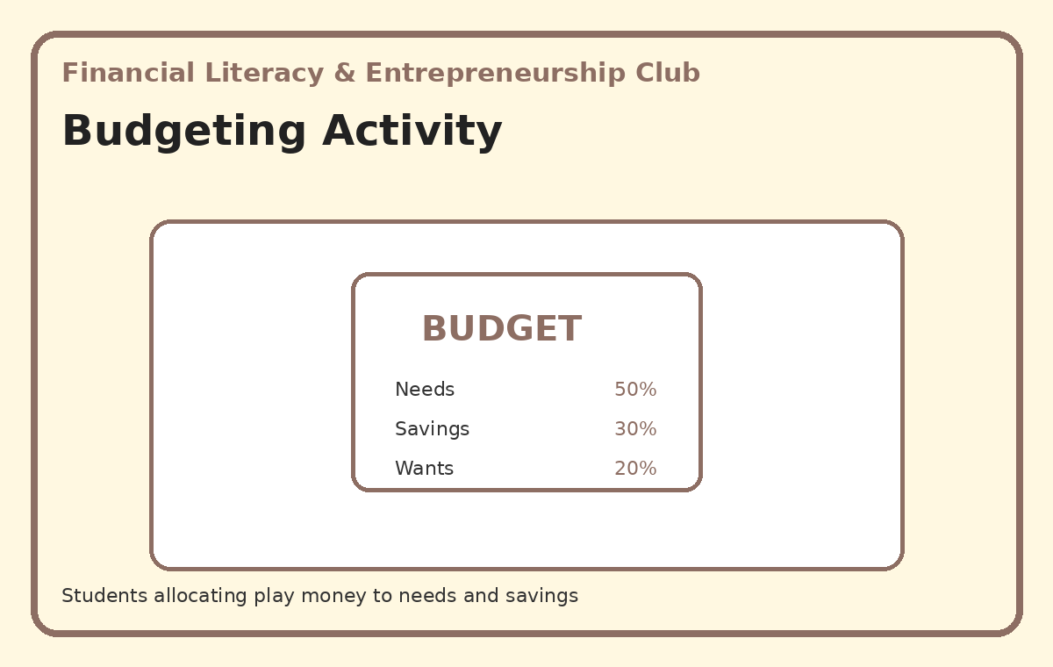
Illustrative activity guide — custom visual created for this action plan
Expected student outcome: A visible/tangible outcome such as a model, display, record, presentation, campaign material, product, performance or service result.
Actual documentation after implementation: Participation record + actual school photographs + short activity report + final student outcome.

3. Saving Challenge
Students track a simple saving goal and reflect on needs versus wants.
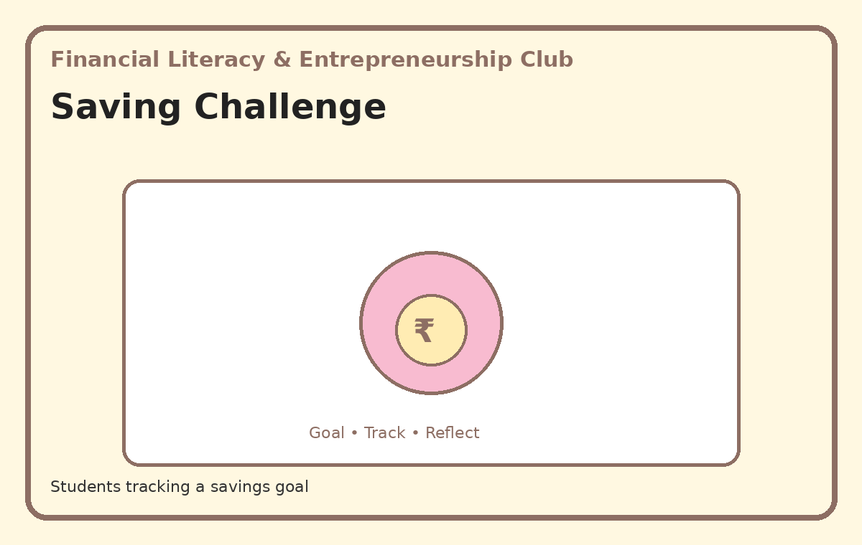
Illustrative activity guide — custom visual created for this action plan
Expected student outcome: A visible/tangible outcome such as a model, display, record, presentation, campaign material, product, performance or service result.
Actual documentation after implementation: Participation record + actual school photographs + short activity report + final student outcome.

4. Student Business Idea Project
Teams develop a simple product/service idea and prepare a mini business pitch.
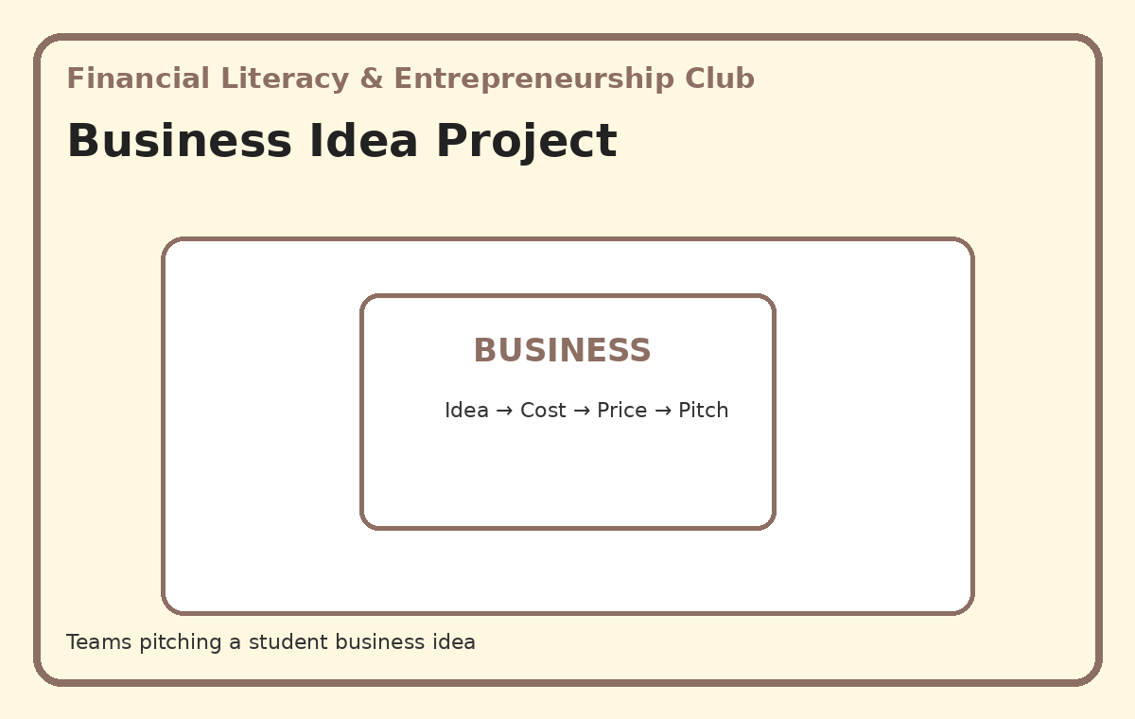
Illustrative activity guide — custom visual created for this action plan
Expected student outcome: A visible/tangible outcome such as a model, display, record, presentation, campaign material, product, performance or service result.
Actual documentation after implementation: Participation record + actual school photographs + short activity report + final student outcome.

5. Student Product Fair
Students display products/ideas and practise explaining value, price and customer needs.
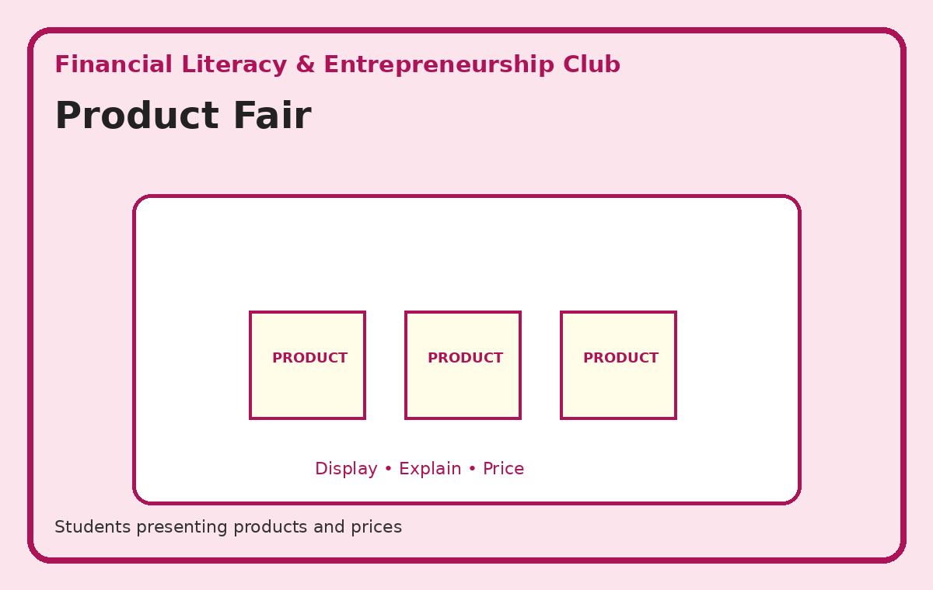
Illustrative activity guide — custom visual created for this action plan
Expected student outcome: A visible/tangible outcome such as a model, display, record, presentation, campaign material, product, performance or service result.
Actual documentation after implementation: Participation record + actual school photographs + short activity report + final student outcome.

7. Social Service & Community Club
Teacher In-Charge(s): Bisma Ma’am
Objectives
- Develop empathy, kindness and social responsibility.
- Encourage students to identify and respond to community needs.
- Promote teamwork and responsible citizenship.
Teacher Responsibility
The in-charge teacher(s) will plan the activity, brief students, organise resources and groups, supervise implementation, ensure a tangible outcome, take photographs of the actual activity, and submit the activity report and evidence to Qurrat Fayaz.

1. Kindness Campaign
Students undertake small, meaningful acts of kindness and create a collective kindness display.
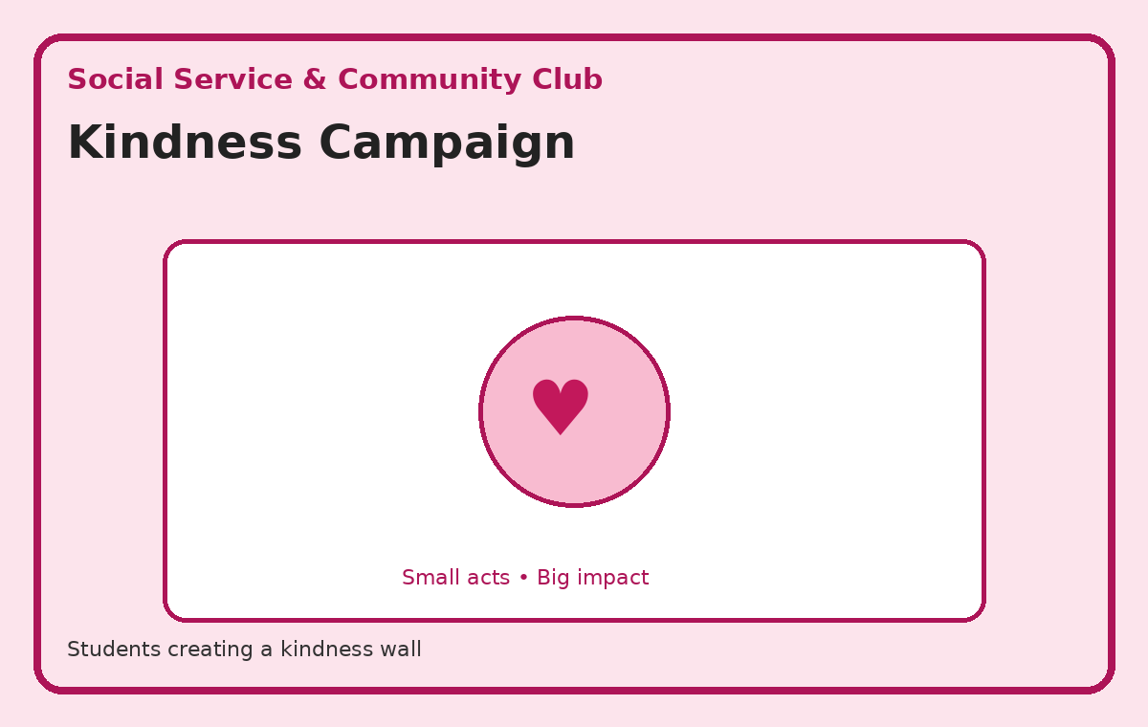
Illustrative activity guide — custom visual created for this action plan
Expected student outcome: A visible/tangible outcome such as a model, display, record, presentation, campaign material, product, performance or service result.
Actual documentation after implementation: Participation record + actual school photographs + short activity report + final student outcome.

2. Donation Drive
Students organise an approved collection of suitable items and sort them responsibly.
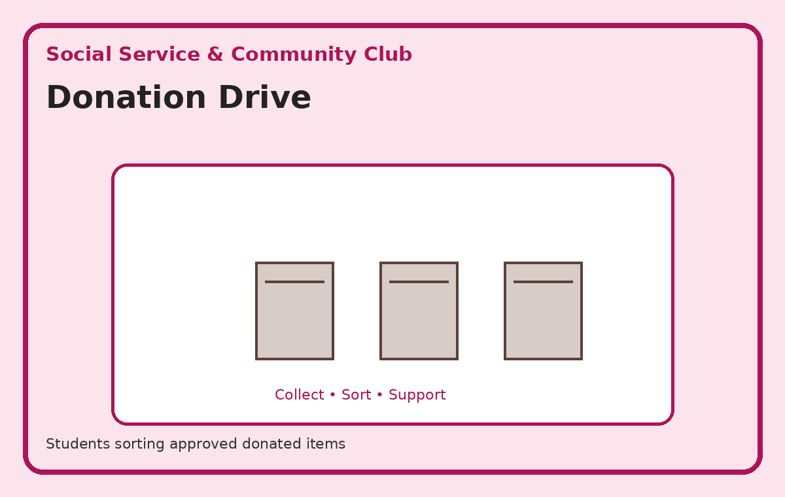
Illustrative activity guide — custom visual created for this action plan
Expected student outcome: A visible/tangible outcome such as a model, display, record, presentation, campaign material, product, performance or service result.
Actual documentation after implementation: Participation record + actual school photographs + short activity report + final student outcome.

3. Community Awareness Campaign
Students prepare posters/messages about a relevant community issue.
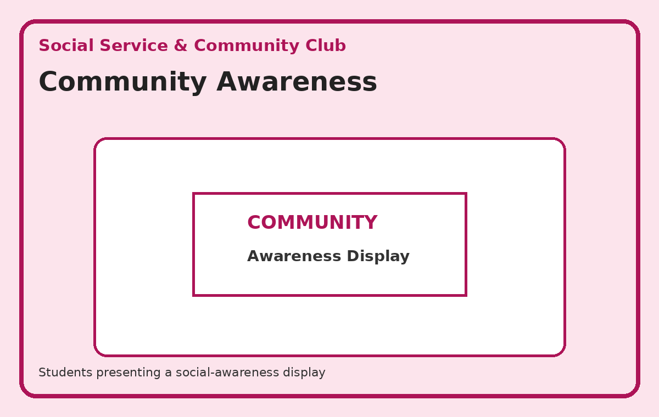
Illustrative activity guide — custom visual created for this action plan
Expected student outcome: A visible/tangible outcome such as a model, display, record, presentation, campaign material, product, performance or service result.
Actual documentation after implementation: Participation record + actual school photographs + short activity report + final student outcome.

4. Service Project
Students complete an approved school/community service task in supervised groups.
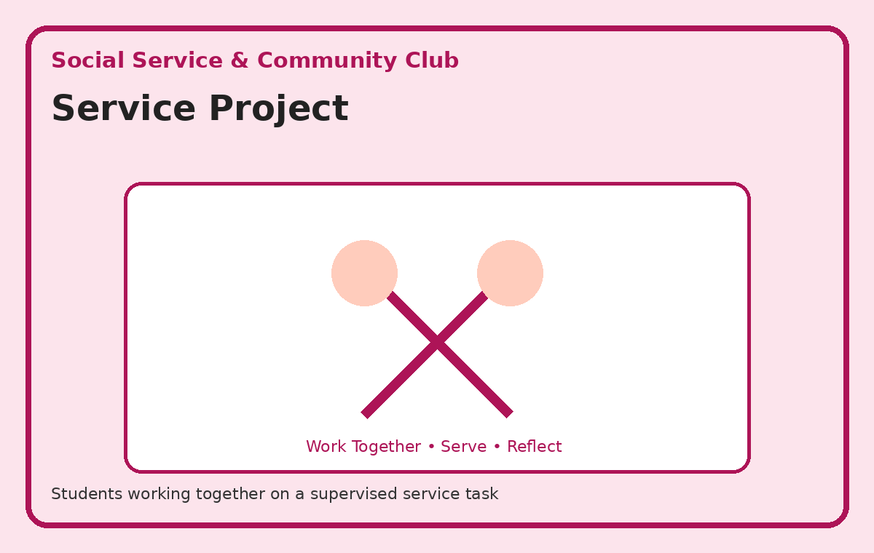
Illustrative activity guide — custom visual created for this action plan
Expected student outcome: A visible/tangible outcome such as a model, display, record, presentation, campaign material, product, performance or service result.
Actual documentation after implementation: Participation record + actual school photographs + short activity report + final student outcome.

5. Gratitude / Helping-Hand Project
Students recognise and thank people who contribute to the school/community.
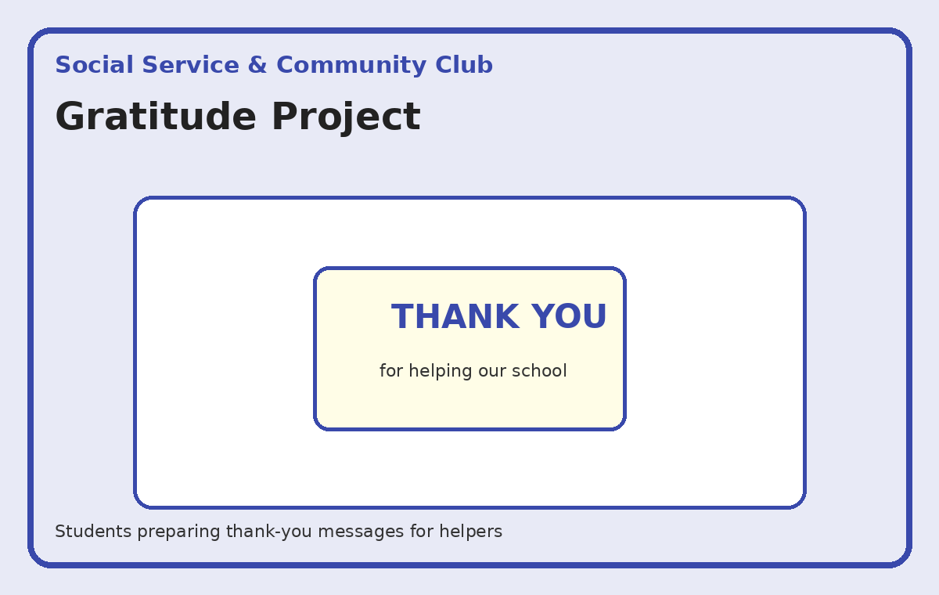
Illustrative activity guide — custom visual created for this action plan
Expected student outcome: A visible/tangible outcome such as a model, display, record, presentation, campaign material, product, performance or service result.
Actual documentation after implementation: Participation record + actual school photographs + short activity report + final student outcome.

8. Astronomy & Space Club
Teacher In-Charge(s): Seema Ma’am
Objectives
- Develop curiosity about space and astronomy.
- Introduce students to planets, stars and the solar system.
- Encourage scientific observation and STEM-related learning.
Teacher Responsibility
The in-charge teacher(s) will plan the activity, brief students, organise resources and groups, supervise implementation, ensure a tangible outcome, take photographs of the actual activity, and submit the activity report and evidence to Qurrat Fayaz.

1. Solar System Model
Groups create and label a 3D solar-system model and explain planetary order.
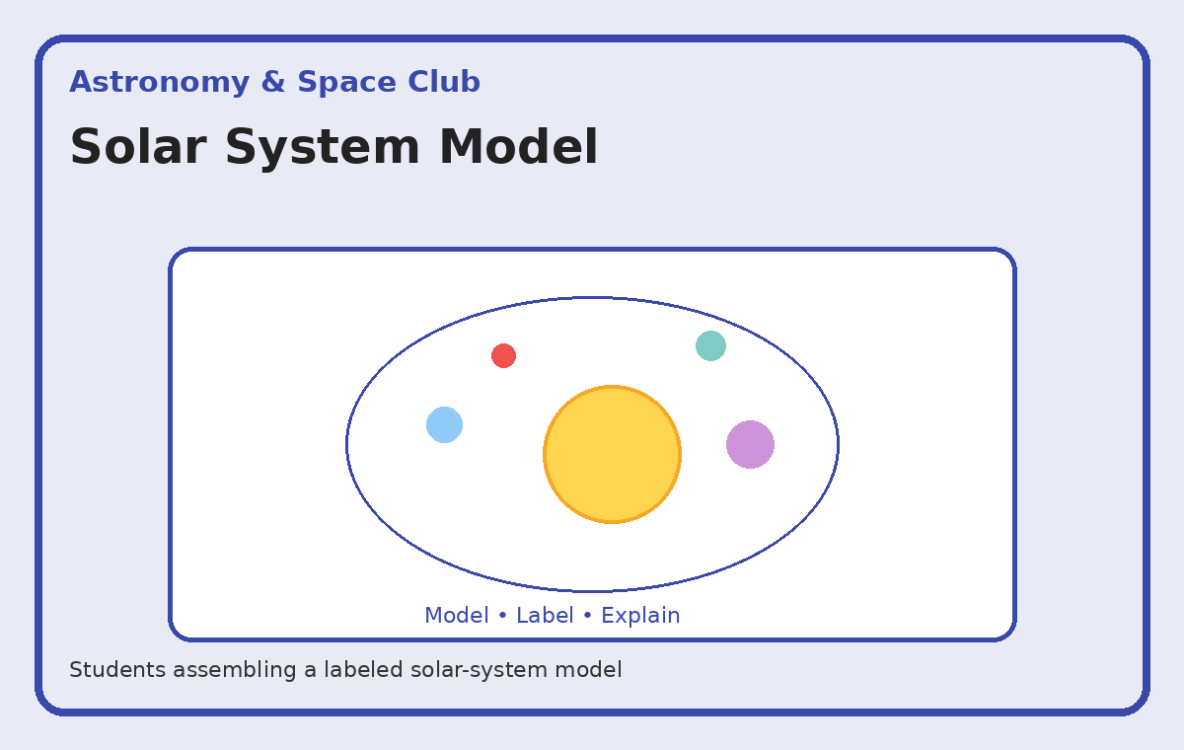
Illustrative activity guide — custom visual created for this action plan
Expected student outcome: A visible/tangible outcome such as a model, display, record, presentation, campaign material, product, performance or service result.
Actual documentation after implementation: Participation record + actual school photographs + short activity report + final student outcome.

2. Constellation Project
Students research selected constellations and prepare labelled charts.
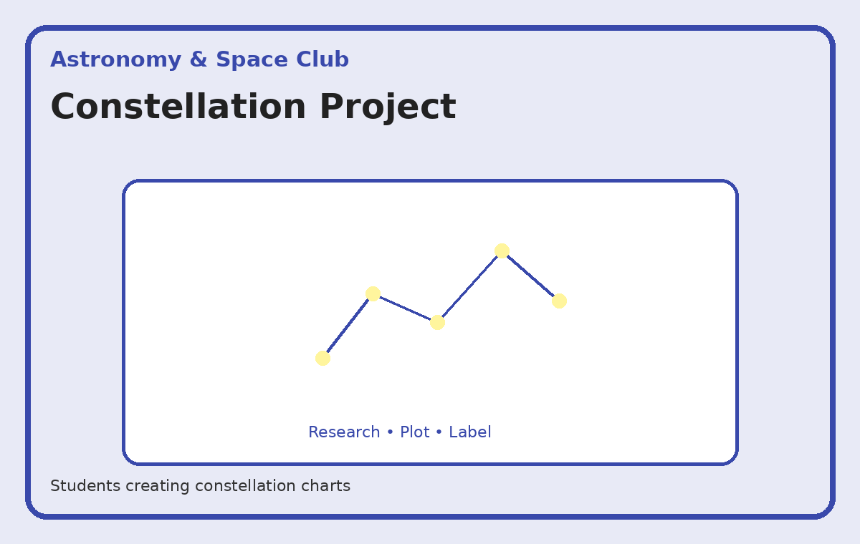
Illustrative activity guide — custom visual created for this action plan
Expected student outcome: A visible/tangible outcome such as a model, display, record, presentation, campaign material, product, performance or service result.
Actual documentation after implementation: Participation record + actual school photographs + short activity report + final student outcome.

3. Space Mission Project
Students research a space mission and present its purpose, journey and major achievement.
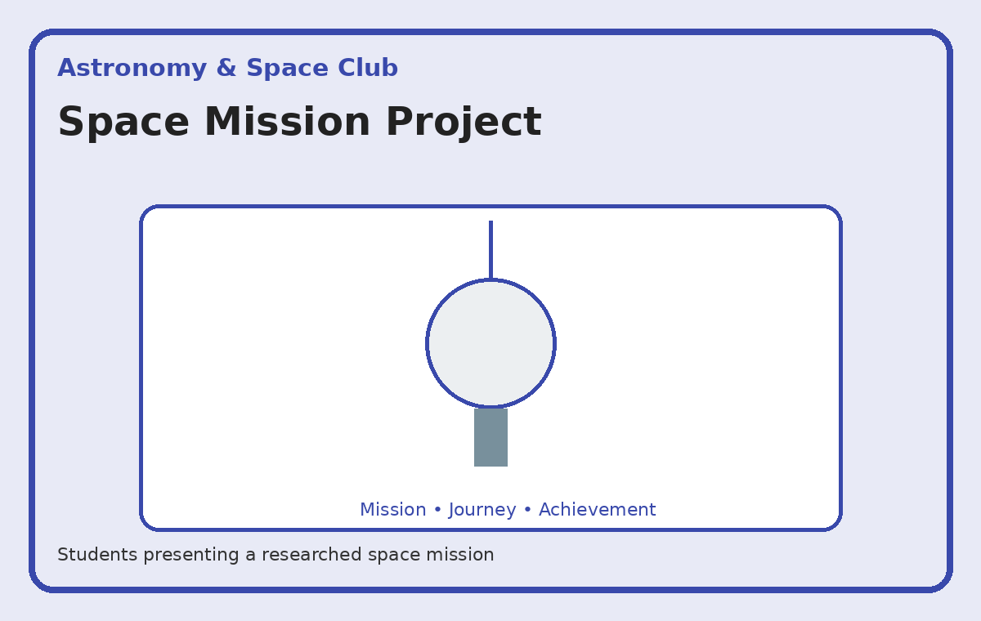
Illustrative activity guide — custom visual created for this action plan
Expected student outcome: A visible/tangible outcome such as a model, display, record, presentation, campaign material, product, performance or service result.
Actual documentation after implementation: Participation record + actual school photographs + short activity report + final student outcome.

4. Astronomy Observation Activity
Students observe the night sky or suitable celestial objects where feasible and safe, then record observations.
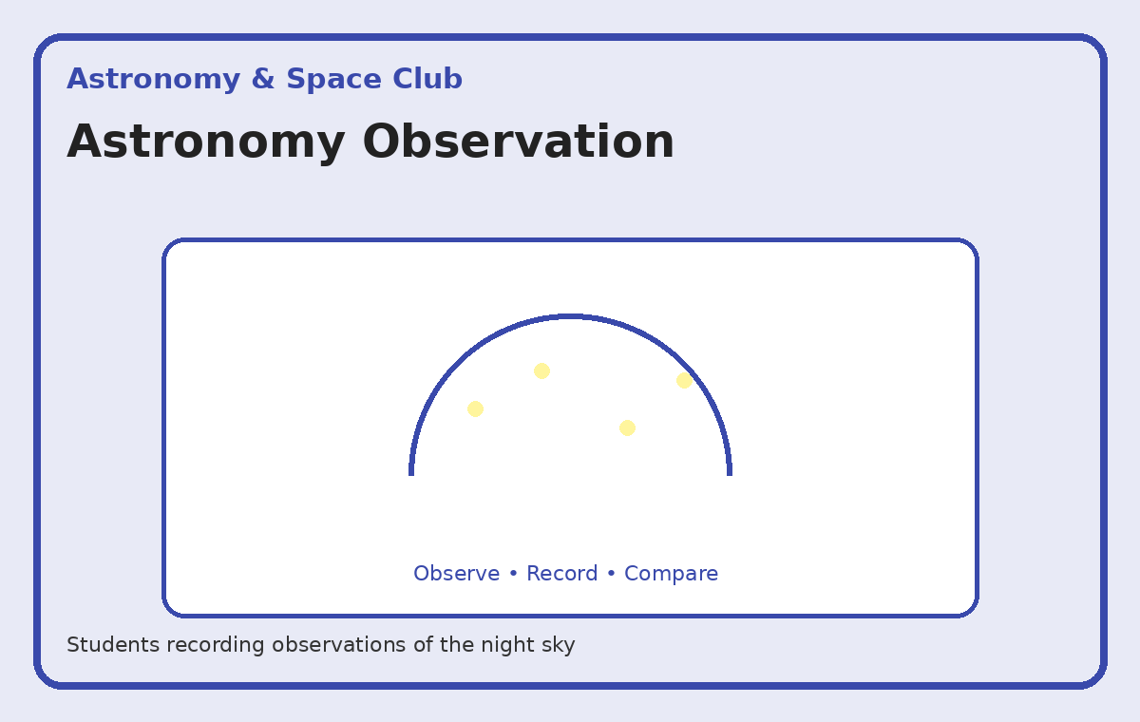
Illustrative activity guide — custom visual created for this action plan
Expected student outcome: A visible/tangible outcome such as a model, display, record, presentation, campaign material, product, performance or service result.
Actual documentation after implementation: Participation record + actual school photographs + short activity report + final student outcome.

5. Space Exhibition
Students display models, charts, mission research and other space-related projects.
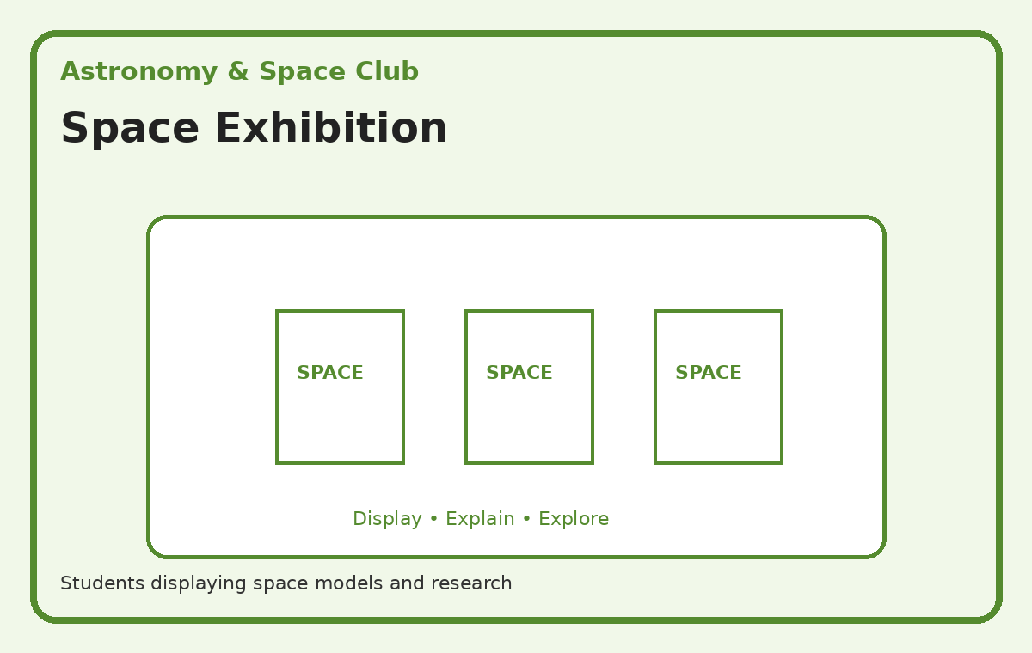
Illustrative activity guide — custom visual created for this action plan
Expected student outcome: A visible/tangible outcome such as a model, display, record, presentation, campaign material, product, performance or service result.
Actual documentation after implementation: Participation record + actual school photographs + short activity report + final student outcome.

9. Islamic Values & Character Club (Akhlaq Club)
Teacher In-Charge(s): Naseer Sir & Tariq Sir
Objectives
- Develop good manners and positive character.
- Encourage honesty, kindness, respect and responsibility.
- Help students apply positive values in daily life.
Teacher Responsibility
The in-charge teacher(s) will plan the activity, brief students, organise resources and groups, supervise implementation, ensure a tangible outcome, take photographs of the actual activity, and submit the activity report and evidence to Qurrat Fayaz.

1. Good Manners Campaign
Students create a practical good-manners display and demonstrate polite behaviour through examples.
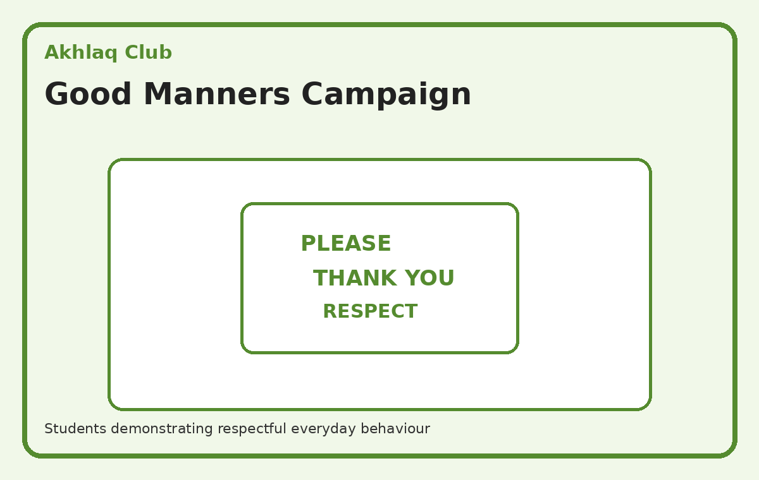
Illustrative activity guide — custom visual created for this action plan
Expected student outcome: A visible/tangible outcome such as a model, display, record, presentation, campaign material, product, performance or service result.
Actual documentation after implementation: Participation record + actual school photographs + short activity report + final student outcome.

2. Kindness Project
Students complete small acts of kindness and share reflections on the impact.
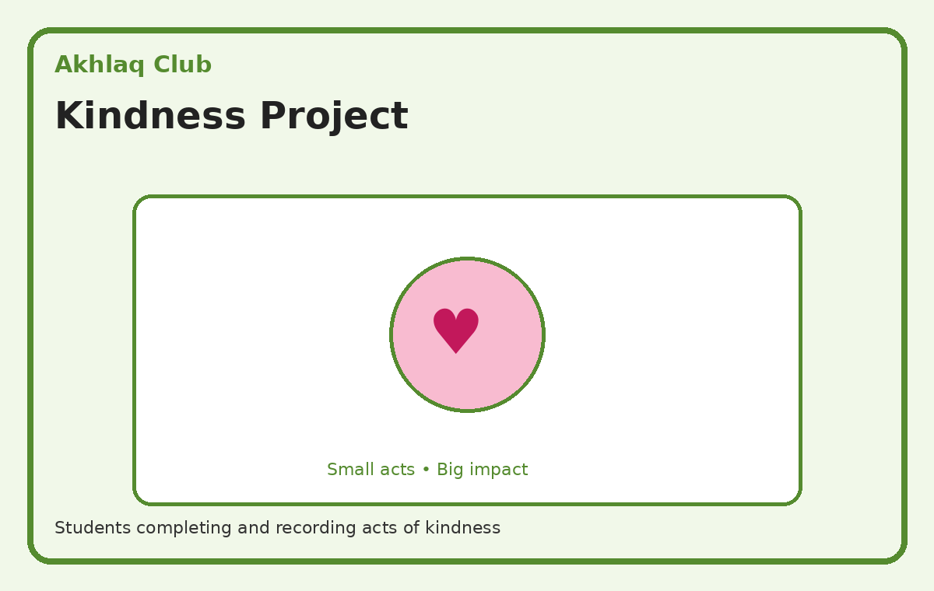
Illustrative activity guide — custom visual created for this action plan
Expected student outcome: A visible/tangible outcome such as a model, display, record, presentation, campaign material, product, performance or service result.
Actual documentation after implementation: Participation record + actual school photographs + short activity report + final student outcome.

3. Honesty Challenge
Students work through age-appropriate situations and identify honest choices.
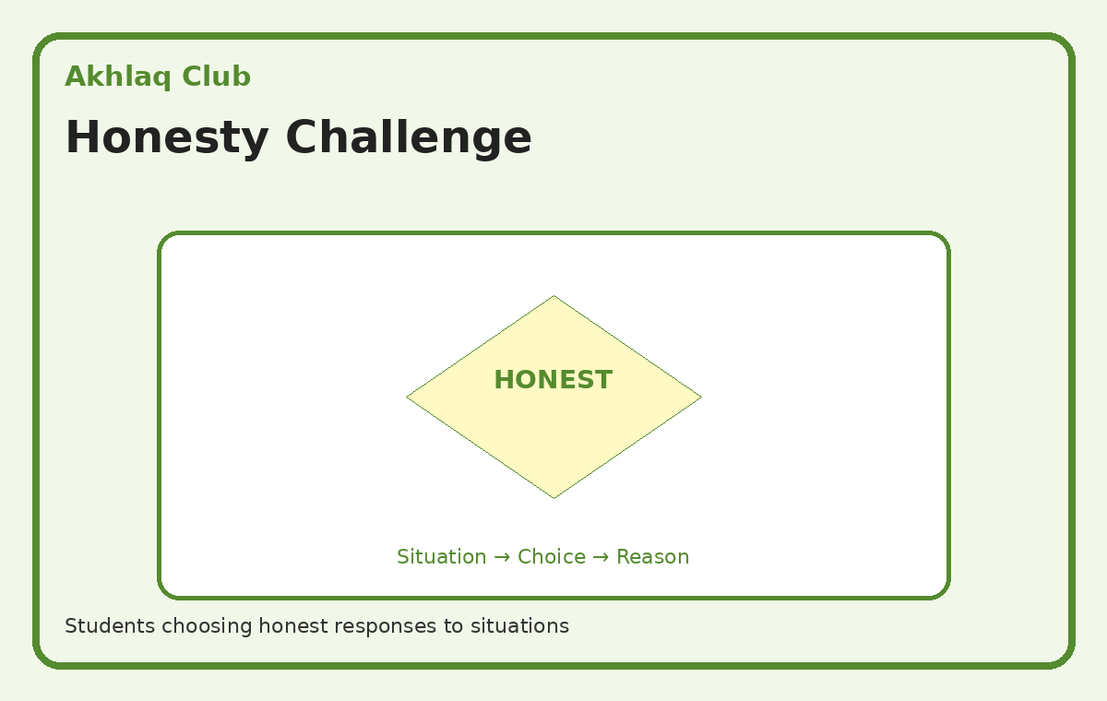
Illustrative activity guide — custom visual created for this action plan
Expected student outcome: A visible/tangible outcome such as a model, display, record, presentation, campaign material, product, performance or service result.
Actual documentation after implementation: Participation record + actual school photographs + short activity report + final student outcome.

4. Respect & Responsibility Campaign
Students create value cards/posters and take responsibility for small school tasks.
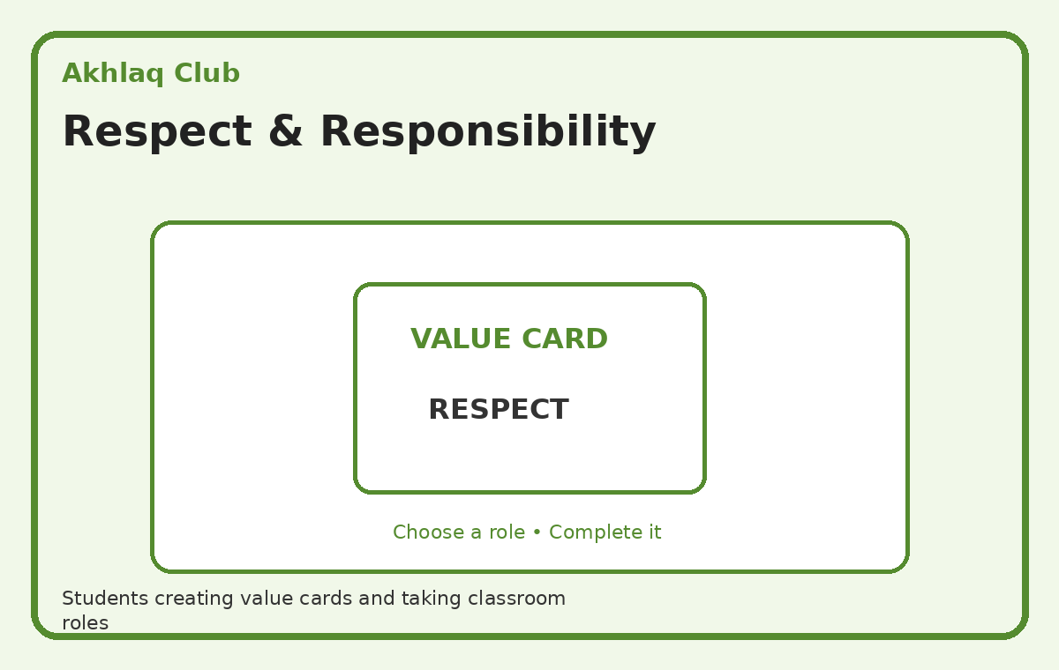
Illustrative activity guide — custom visual created for this action plan
Expected student outcome: A visible/tangible outcome such as a model, display, record, presentation, campaign material, product, performance or service result.
Actual documentation after implementation: Participation record + actual school photographs + short activity report + final student outcome.

5. Values-Based Story / Role Play
Students perform short situations showing honesty, respect, responsibility and kindness.
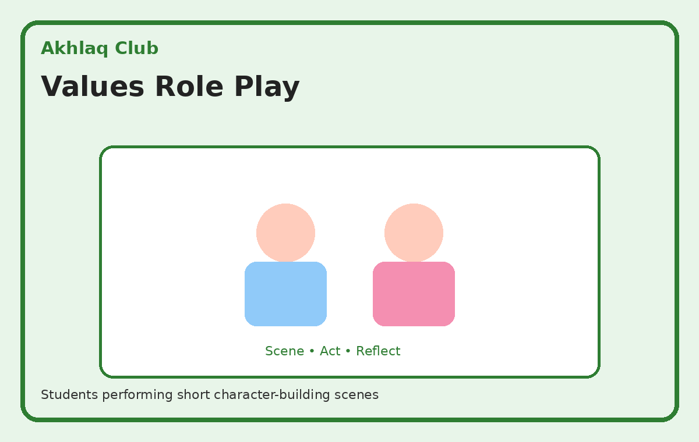
Illustrative activity guide — custom visual created for this action plan
Expected student outcome: A visible/tangible outcome such as a model, display, record, presentation, campaign material, product, performance or service result.
Actual documentation after implementation: Participation record + actual school photographs + short activity report + final student outcome.

5. Implementation Timeline
Phase | Timeline | Key Actions
Phase 1 – Constitution | Week 1 | Finalise teachers, student membership, objectives and action plans; brief all in-charges.
Phase 2 – Launch | Week 2 | Introduce clubs, conduct the first activity of every club and start club portfolios.
Phase 3 – Regular Implementation | Monthly | Each club conducts at least one substantial activity/project and submits evidence.
Phase 4 – Review | End of Each Term | Review participation, outcomes, documentation and achievements; plan improvements.

6. Master Club Monitoring Sheet
Club | Teacher In-Charge | First Activity | Date | Students | Outcome | Photo/Report Submitted
Environment & Eco Club | Mudassir Sir & Javed Sir | School Plantation / Adopt-a-Plant Drive
Robotics & AI Club | Aamir Sir & Shahista Ma’am | Introduction to Coding
Critical Thinking Club | Iram Ma’am & Sharika Ma’am | GK Challenge
Arts & Creativity Club | Gurmeet Ma’am & Maheen Ma’am | School Wall Project
Sports & Fitness Club | Rukhsana Ma’am & Farooq Sir | Fitness Challenge
Financial Literacy & Entrepreneurship Club | Falak Ma’am, Henna Ma’am & Ghulam Muhammad Wani Sir | Mock Market
Social Service & Community Club | Bisma Ma’am | Kindness Campaign
Astronomy & Space Club | Seema Ma’am | Solar System Model
Islamic Values & Character Club (Akhlaq Club) | Naseer Sir & Tariq Sir | Good Manners Campaign

7. Activity Documentation Format
Club Name: ______________________________________________
Activity/Project: ______________________________________________
Date: ______________________________________________
Teacher In-Charge(s): ______________________________________________
Number of Students Participated: ______________________________________________
Objective: ______________________________________________
Brief Description: ______________________________________________
Student Roles/Participation: ______________________________________________
Outcome/Product Created: ______________________________________________
Actual Photographs Attached: ______________________________________________
Teacher's Observation: ______________________________________________
Follow-up/Next Step: ______________________________________________

8. Photographic Documentation Protocol
- The visuals in this action plan are illustrative planning guides only.
- Actual photographs should be taken during every major activity and attached to the activity report.
- Prefer photographs showing students actively participating, the process and the final outcome.
- Add the activity name, date, venue and a short caption to actual photographs.
- I will collect, review, organise and archive the actual photographs and reports.
- Follow the school's applicable student consent, safeguarding and media-use requirements.

9. Monitoring & Management Review
The management/academic team may review each club on the basis of activity quality, student participation, project outcomes, documentation, photographs, exhibitions/competitions, achievements and community impact.
I will be responsible for checking that all clubs are functioning properly, coordinating with the respective in-charges, maintaining the consolidated documentation and presenting the progress of the clubs to management.

10. Approval
Prepared / Coordinated by | Reviewed by | Approved by
Qurat Fayaz | ________________ | ________________

